**Project Design**

**Project Ethos**

**4/5/2020**

ISM6106

**Group 1**

Anthony Ramos

Gustavo Pinedo

Miguel Acuna

Philip DaCosta

**Roles and Responsibilities**

**Team ISEC**

|  |  |  |
| --- | --- | --- |
| **Team Members** | **Role** | **Responsibilities** |
| Anthony Ramos | Project Lead | 1. Lead Code Dev, Manage Eclipse 2. Manage Github |
| Gustavo Pinedo | QA Tester | 1. Check the diagrams for possible errors that will cause bugs or errors 2. Run models to ensure all works as planned and give feedback if any problems 3. Assist QA of eclipse and documentation 4. Assist in presentation |
| Miguel Acuna | Director of IT infrastructure | 1. Manage the Access Management Model Design 2. Manage the Class Diagram 3. Manage the State Diagram |
| Philip DaCosta | Application Developer Manager | 1. Project Manager- Facilitation of project and document Management 2. Assist Lead Code dev and QA Eclipse code 3. Manage the Database Implementation 4. Manage the Group Presentation |

**Specification Statement**

Per our project proposal, below, you will find the system’s specifications and features to be implemented:

1. **System Connectors - API**
   1. Develop a system connector
   2. Develop the ability to write protocols in order to interact with the systems
2. **Database Interface**
   1. Connect the systems to create a centralized User Access Control matrix.
3. **User Management Interface**
   1. Must be able to add users
   2. Must be able to remove and terminate users
      1. Use Active and end dates
   3. Must be able to suspend user access
   4. Must have the ability to assign user access
   5. Ability to assign and remove software & physical access
   6. Ability to assign and remove physical ID cards for user access
4. **Access Group Management**
   1. Develop Groups
      1. Must be able to add groups
      2. Must be able to remove and add groups
      3. Must be able to suspend groups
      4. Must have the ability to assign users to a group
5. **Reporting Capabilities**
   1. Develop Reports
      1. The ability to report on system licenses
      2. The ability to report on employee management events
      3. The ability of successful and failure events
      4. The ability to provide a log of user access history
6. **Connect to Database**
   1. Connect to a database for backup and reporting

The project will contain the specifications defined in the final project and will be presented to the Executive Board on April 18th, 2020, and the final implementation will be concluded by April 22nd, 2020, in accordance with Dr. Sengupta, CEO.

**Github:**  **https://github.com/aramo089/ProjectEthos**

**Class Diagram**

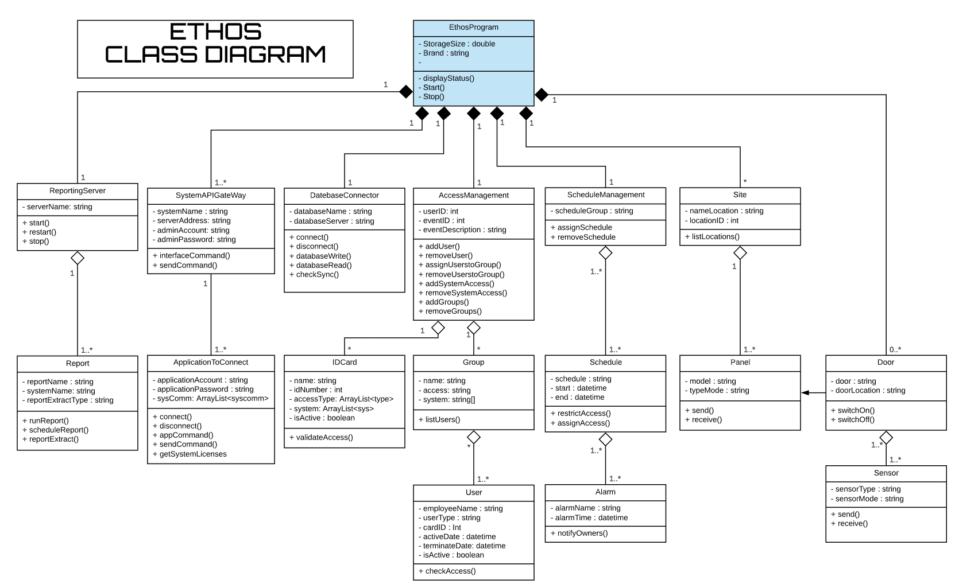

**State Diagram**

